Name Sergiy Palguyev
GTID: spalguyev3
Machine Learning for Trading (CS 7646) - Manual Strategy Report
- Technical Indicators
In this project, three technical indicators were considered. The three indicators are variants on the Simple Moving Average (SMA), Bollinger Band (BB) and Momentum (MA) technical indicators. Their details are outlined below
  - The SMA is calculated by adding a stock's prices over a certain period and dividing the sum by the total number of periods. SMA indicator is based on the standard SMA but with two different windows to act as BUY/SELL signals. The first SMA has a window of 10 while the second SMA has a window of 20. Where the SMA-10 crosses SMA-20 downwards, will be considered a SELL signal. Where SMA-10 crosses SMA-20 upwards, will be considered a BUY signal.
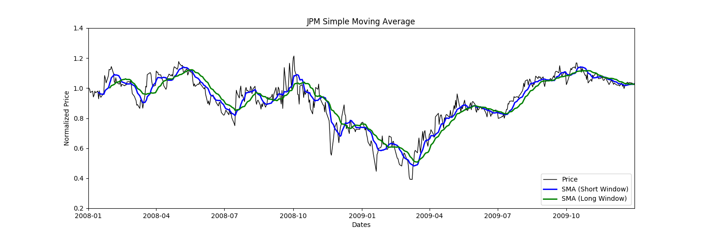

  - Bollinger Bands are 2 lines which are located 2 standard deviations above and below the mean of the stock prices. Standard deviation is a mathematical formula that measures volatility, showing how the stock price can vary from its true value. By measuring price volatility, BB adjust themselves to market conditions. The BB indicator is ruled such that whenever the price reaches above the BB-upper then dips below it, will be considered as s SELL signal. Conversely whenever the price dips below the BB-lower then rises above, will be considered a BUY signal.
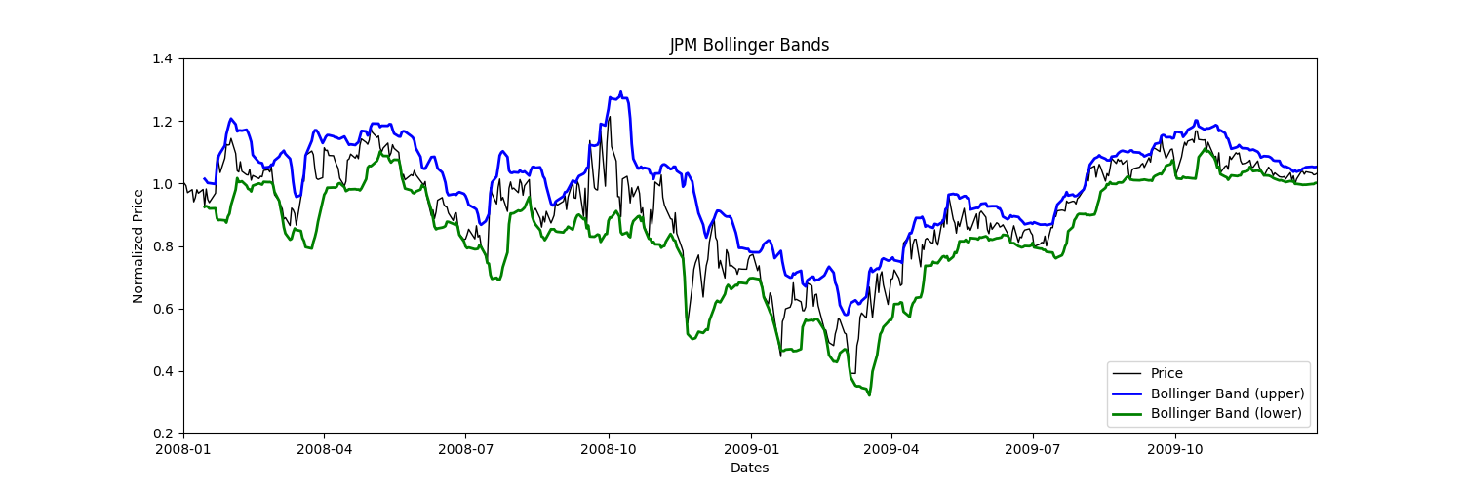
  - The Momentum indicator is a measure of the rate of acceleration or deceleration of price increase of a stock. This indicator is used to determine if a SELL/BUY signal is about to occur.
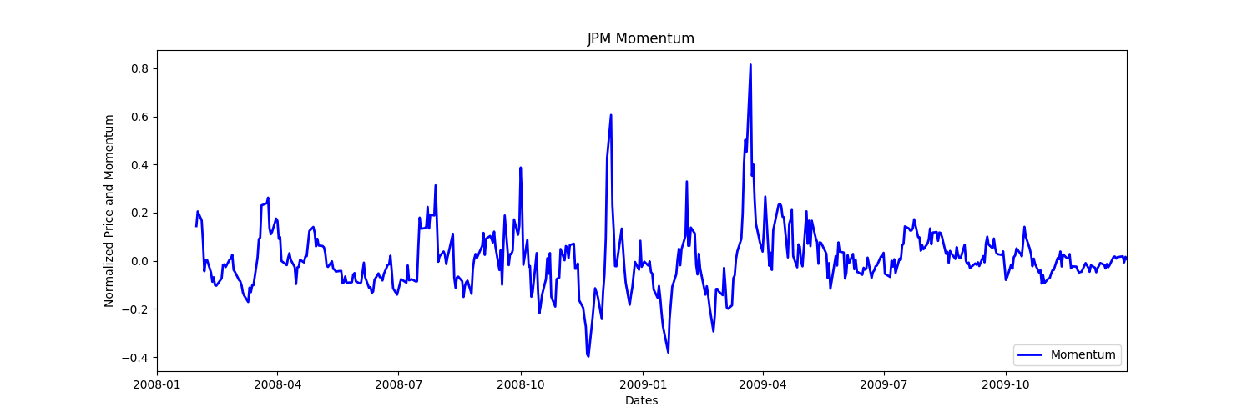

- Theoretically Optimized Strategy
In this theoretical strategy, we are able to peek into the future. For each day, if we see that the next day will be a price drop, we short the stock. Conversely, if we see that the next day will be a price increase, we purchase the stock. This way we are always in an advantaged state.
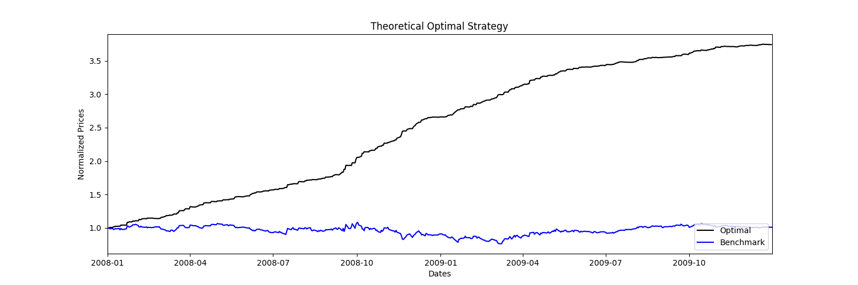
- Manual Rule-Based Strategy
In this strategy, we use the indicators and rules described in section 1 to BUY/SELL the stocks. Each strategy is OR’ed with each other, rather than AND’ed. This facilitates the shortcomings and benefits of each strategy to cancel each other out. As we see from the graph below, The manual strategy, although not ideal, manages to stay above the baseline as time goes on.
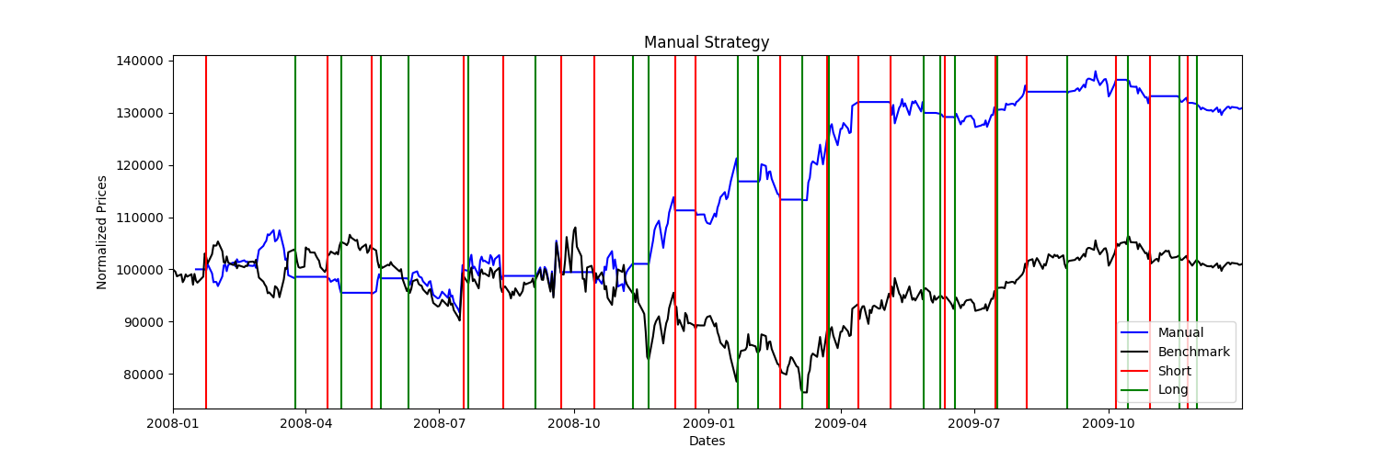

- Comparative Analysis
As we see from the graph below, running the Manual Strategy code for Out-Of-Sample data was also successful, as the portfolio manages to outperform the benchmark.
